**Department of Computer Science**

**M.Sc. Computer Science I**

**SEMESTER II**

**Synopsis**

**Group Members:**

**Name & Roll No: Dhimar Arin Avinash 246203**

**Name & Roll No: Pare Prajakta Prabhakar 246249**

**Name & Roll No: Dighe Atharva Ajey 243605**

**Title of the Project: BookAura**

**Description:**

Our web application, **BookAura**, is a comprehensive platform that connects readers, authors, and publishers. Authors can publish their books on the platform, either privately or publicly (subject to moderation approval). Readers can browse and access a wide variety of books, listen to audiobooks in multiple languages, and bookmark their favourites. The platform also provides data-driven insights and analytics for authors about their uploaded books based on views, likes, and user engagement. Publishers and moderators oversee approvals and ensure quality content.

**Functionalities:**

* Comprehensive library of books for users to read, listen to, and bookmark.
* Author registration with the ability to publish private or public books.
* Moderation for public book approvals by dedicated publishers and moderators.
* Classification of books based on genres, authors, and popularity.
* User registration with features such as subscription, bookmarking, history, and multi-language audiobook support (English, Hindi, Marathi).
* Data analysis of books based on views, likes, and comments.
* Insights and analytics for authors about their published books.

**Flowchart of the application:**

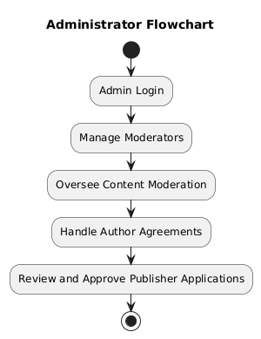

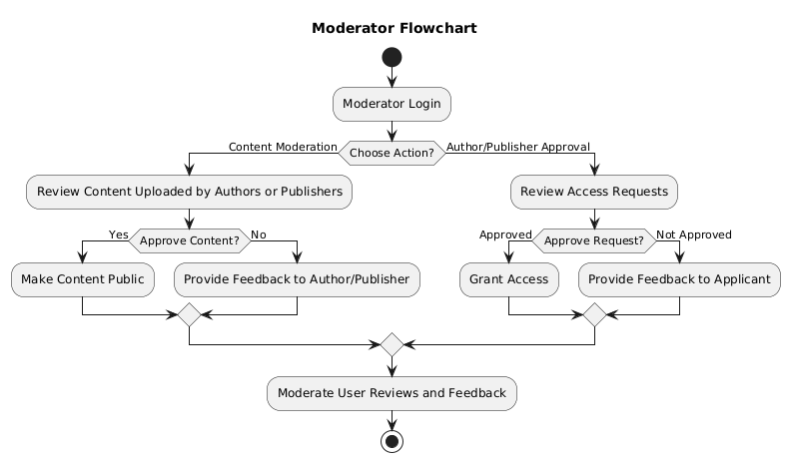

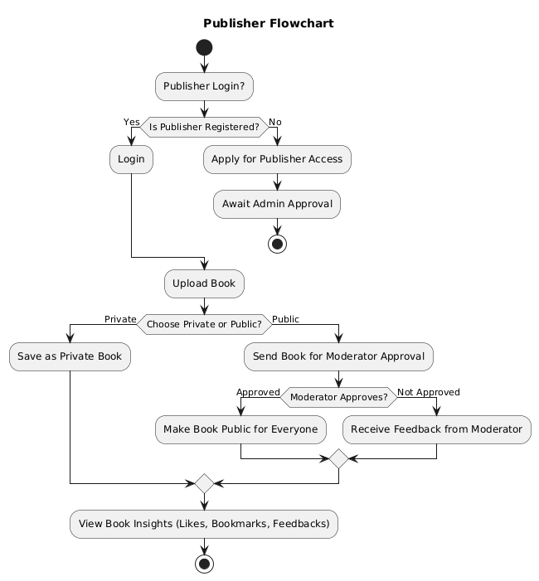

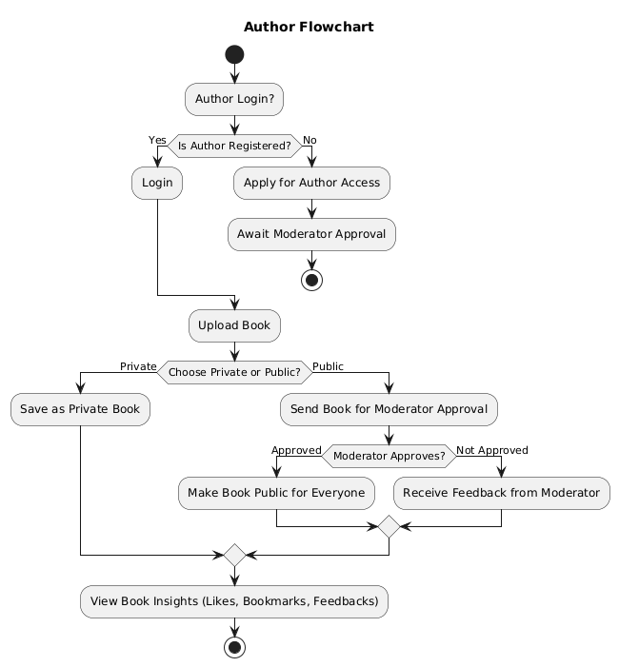

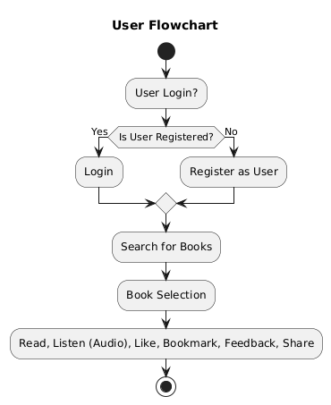

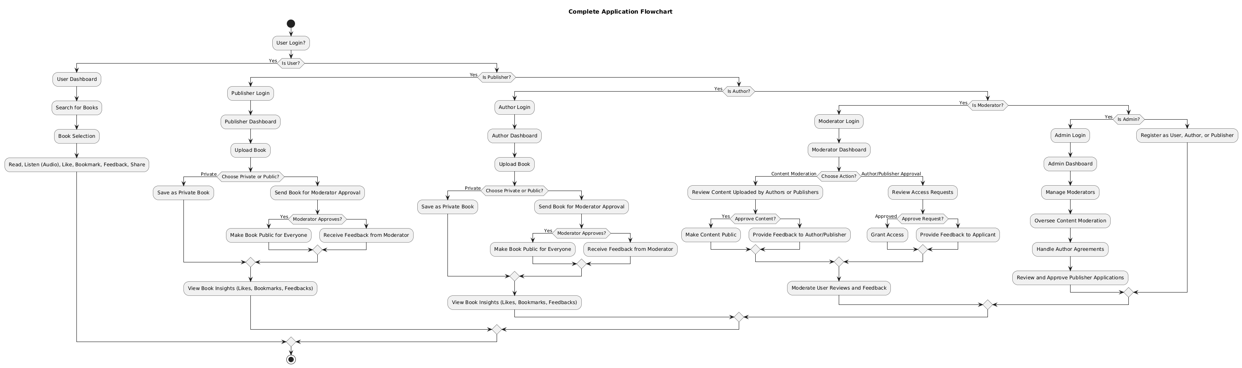

**User Module:**

* User registration, login, and profile management.
* Book browsing, bookmarking, audiobook listening, and history tracking..

**Author Module:**

* Author registration and agreement for publishing books.
* CRUD operations for book management (private and public publishing).
* Access to insights and analytics.

**Publisher Module:**

* Publisherregistration and agreement for publishing books.
* CRUD operations for book management (public publishing).
* Access to insights and analytics.

**Moderator Module:**

* Manage and approve public book requests.
* Oversee reviews, feedback, and ensure content quality.

**Admin Module:**

* Manage all users, authors, and publishers.
* Perform data analysis and manage platform settings.

**Technologies:**

* **FrontEnd** : HTML, CSS (with TailWind CSS), JavaScript , React
* **Database** : MySQL , Firebase
* **BackEnd** : Flask
* **Audio Processing** : Text-to-speech APIs/Python Libs for audiobook generation (English, Hindi, Marathi)